**Project Design Phase-II**

**Data Flow Diagram & User Stories**

|  |  |
| --- | --- |
| Date | 03 October 2022 |
| Team ID | PNT2022TMID50730 |
| Project Name | Web phishing Detection |
| Maximum Marks | 4 Marks |

**Data Flow Diagrams:**

A Data Flow Diagram (DFD) is a traditional visual representation of the information flows within a system. A neat and clear DFD can depict the right amount of the system requirement graphically. It shows how data enters and leaves the system, what changes the information, and where data is stored.

**Example:** [**(Flow diagram)**](https://developer.ibm.com/patterns/visualize-unstructured-text/)

Web phishing Detection

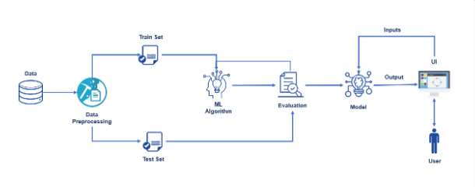

Dataset

Data preprocessing

Train & Test dataset

Algorithm

Output

Final Model

Input

**User Stories**

Use the below template to list all the user stories for the product.

| **User Type** | **Functional Requirement (Epic)** | **User Story Number** | **User Story / Task** | **Acceptance criteria** | **Priority** | **Release** |
| --- | --- | --- | --- | --- | --- | --- |
| Data | Data pre-processing | USN-1 | Pre-processing the data | I can upload dataset | High | Sprint-1 |
|  | Feature Extraction | USN-2 | Based on URL  Based on Domain Name  Based on Page Based Features  Based on content | I can upload features | High | Sprint-2 |
| Input (user) | Data Classification | USN-3 | URLs Detection  Content Identification | I can detect URLs | High | Sprint-3 |
|  | Classifier Selection | USN-4 | Create multiple datasets  Build multiple classifiers  Combine classifiers  Finalize Classifier | I can select the model | High | Sprint-4 |
| Input (user) |  |  | Same as the process |  | Medium |  |